**Homework 1**

***Python S3 Command-line Interface***

**Student**: Patrick Walsh

**School**: University of Maryland Global Campus

**Course**: SDEV 400 6980

**Date**: 6/25/2021

**Professor**: Dr. Craig Poma

1. (20 points) Using the AWS Management Console, create two (2) S3 buckets with DNS-compliant names of your choice. In each of the buckets create 2 folders named as follows:

* Jobs
* Support

Once you have created the buckets and folders, provide screen captures clearly demonstrating your successful completion of this step. Be sure to provide a figure number and title as well as a description of to describe the images. Your screen captures should clearly show the bucket named created and folders for each bucket.

**Figure 1**

*Screen capture showing the two buckets created in S3.*

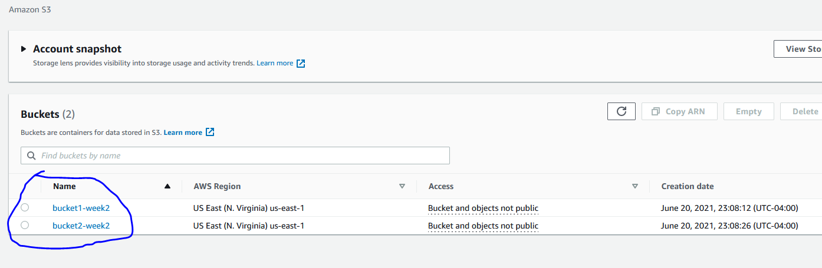

*Note*. From S3 Management Console.

**Figure 2**

*Screen capture showing folders in bucket1-week2.*

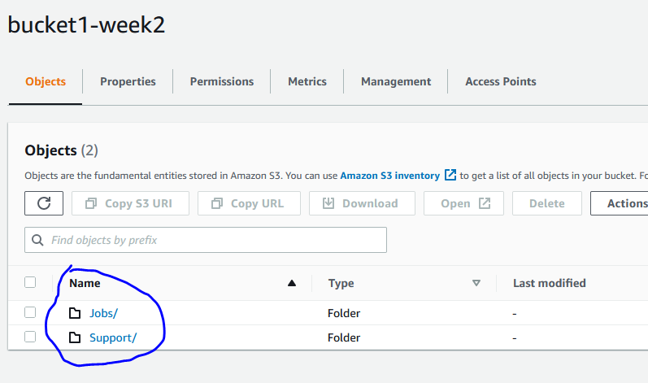

*Note*. From S3 Management Console.

**Figure 3**

*Screen capture showing folders in bucket2-week2.*

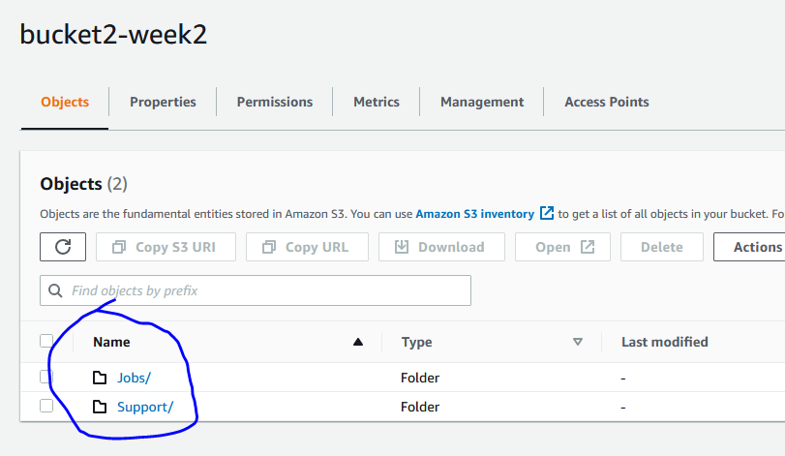

*Note*. From S3 Management Console.

1. (10 points) Using the AWS Management Console, copy 2 files (or your choice) to each of the 2 folders you created for your S3 buckets. (This means a total of 8 files will be moved to the S3 buckets.) Once you have completed steps 1 and 2, provide screen captures clearly demonstrating your successful completion of these steps. Be sure to provide a figure number and title as well as a description of the screen captures. Your screen captures should clearly show the bucket names created, the folders residing in each bucket and the files sent to each folder.

**Figure 4**

*Screen capture showing files copied to bucket1-week2 ‘Jobs’ folder.*

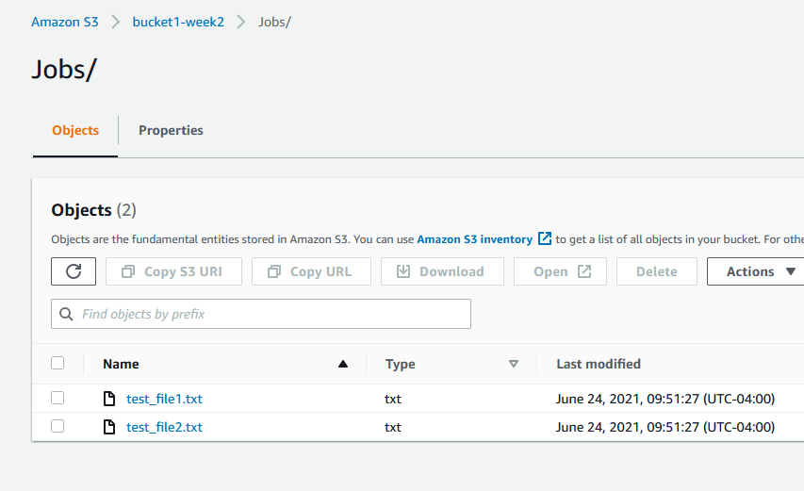

*Note*. From S3 Management Console.

**Figure 5**

*Screen capture showing files copied to bucket1-week2 ‘Support’ folder.*

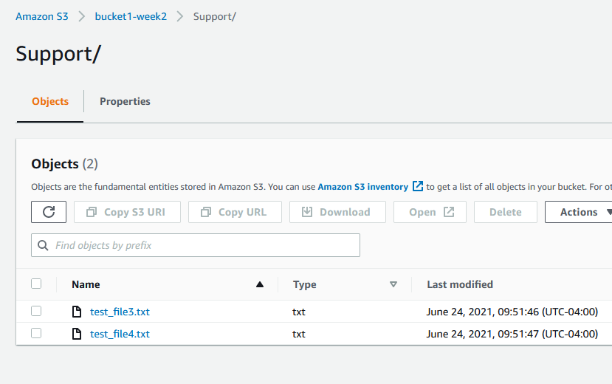

*Note*. From S3 Management Console.

**Figure 6**

*Screen capture showing files copied to bucket2-week2 ‘Jobs’ folder.*

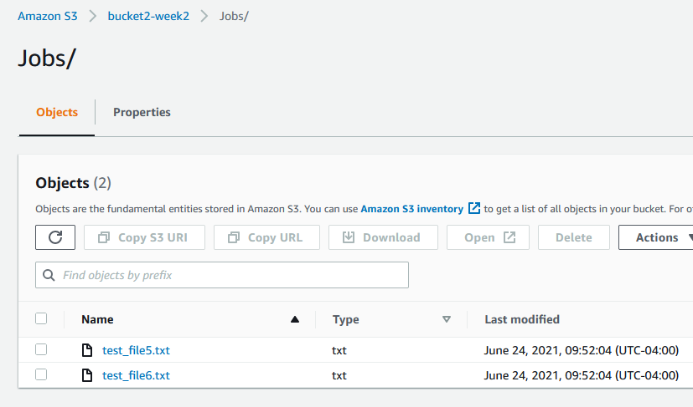

*Note*. From S3 Management Console.

**Figure 7**

*Screen capture showing files copied to bucket2-week2 ‘Support’ folder.*

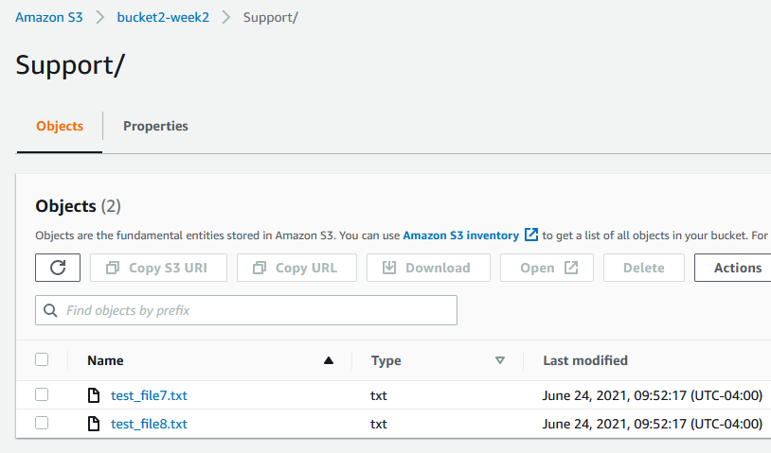

*Note*. From S3 Management Console.

1. (50 points) Using the Cloud9 IDE within your assigned AWS Educate classroom, write and provide documentation supporting a Python command line menu-driven interface application that performs the following AWS S3 functionality:
2. **Creates a S3 bucket with the name consisting of your firstname, lastname and a random 6-digit suffix. For example, the following would be a possible bucket name jimrobertson-321921.**

Source code was taken from Amazon (create_bucket.py, 2019) and modified to accomplish task 3a. Below are screen shots showing successful completion of this task.

**Figure 8a**

*Main menu screen of application, creating a bucket.*

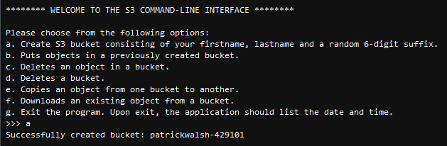

*Note*. From AWS Cloud9 IDE.

**Figure 8b**

*Screen shot showing bucket created in S3.*

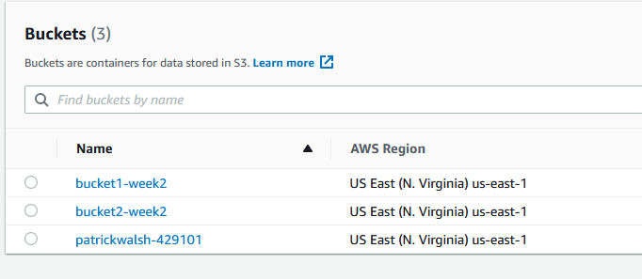

*Note*. From S3 Management Console.

1. **Puts objects in a previously created bucket.**

Source code was taken from Amazon (put_object.py, 2019) and modified to accomplish task 3b. Below are screen shots showing successful completion of this task.

**Figure 9a**

*Main menu screen of application, putting object into bucket.*

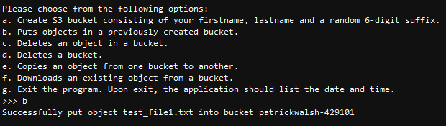

*Note*. From AWS Cloud9 IDE.

**Figure 9b**

*Screen shot showing object put into bucket in S3.*

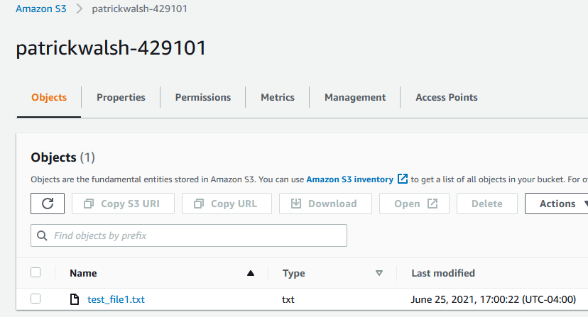

*Note*. From S3 Management Console.

1. **Deletes an object in a bucket.**

Source code was taken from Amazon (delete_object.py, 2019) and modified to accomplish task 3c. Below are screen shots showing successful completion of this task.

**Figure 10a**

*Main menu screen of application, deleting object from bucket.*

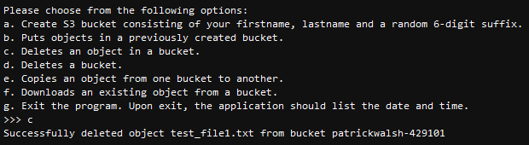

*Note*. From AWS Cloud9 IDE.

**Figure 10b**

*Screen shot showing object deleted from bucket in S3.*

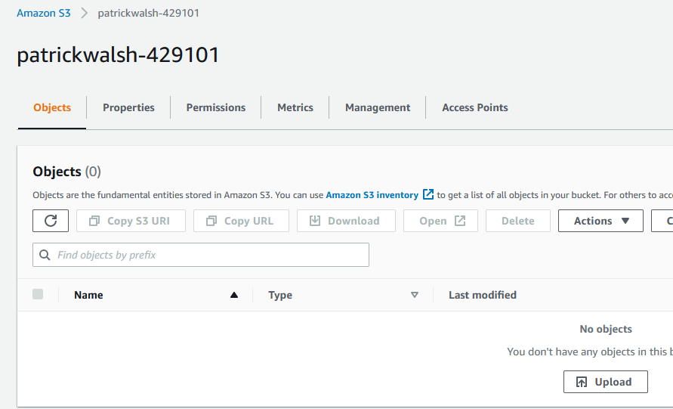

*Note*. From S3 Management Console.

1. **Deletes a bucket.**

Source code was taken from Amazon (delete_bucket.py, 2019) and modified to accomplish task 3d. Below are screen shots showing successful completion of this task.

**Figure 11a**

*Main menu screen of application, deleting bucket.*

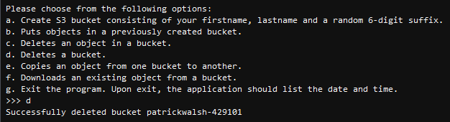

*Note*. From AWS Cloud9 IDE.

**Figure 11b**

*Screen shot showing bucket deleted from S3.*

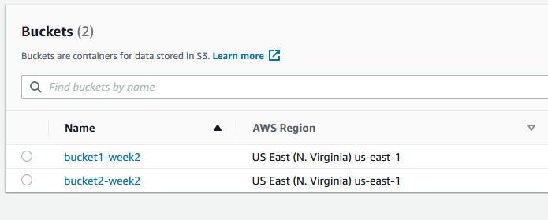

*Note*. From S3 Management Console.

1. Copies and object from one bucket to another.

Source code was taken from Amazon (copy_object.py, 2019) and modified to accomplish task 3e. Below are screen shots showing successful completion of this task.

**Figure 12a**

*Main menu screen of application, copying object from one bucket to another.*

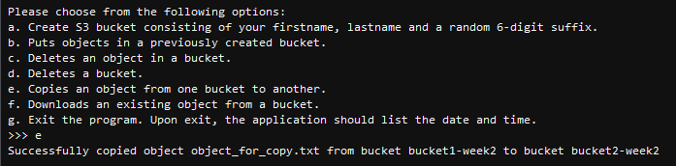

*Note*. From AWS Cloud9 IDE.

**Figure 12b**

*Screen shot showing object copied from one bucket to another.*

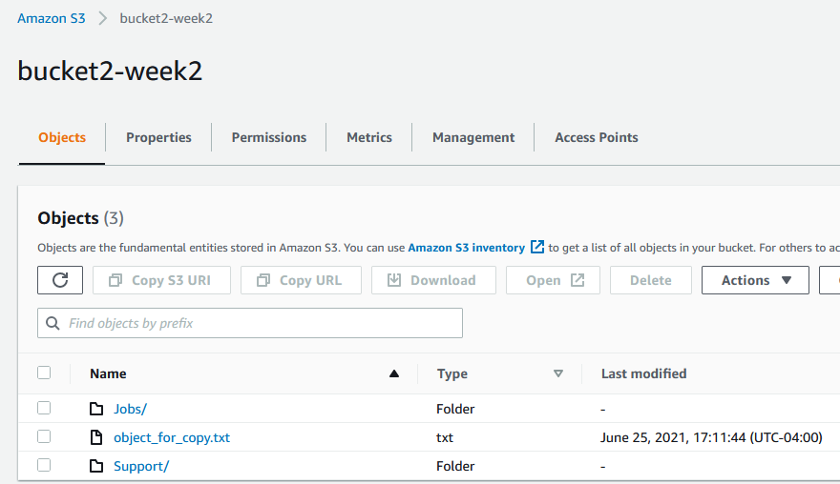

*Note*. From S3 Management Console.

1. Downloads an existing object from a bucket.

Source code was taken from Amazon (s3-python-example-download-file.py, 2018) and modified to accomplish task 3f. Below are screen shots showing successful completion of this task.

**Figure 13a**

*Main menu screen of application, downloading object from bucket.*

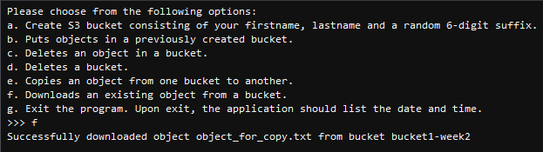

*Note*. From AWS Cloud9 IDE.

**Figure 13b**

*Screen shot showing object downloaded from bucket.*

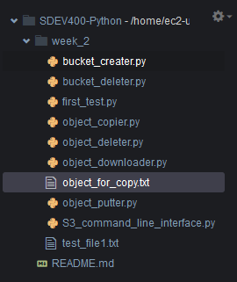

*Note*. From AWS Cloud9 IDE.

1. Exit the program. Upon exit, the application should list the date and time.

**Figure 14**

*Main menu screen of application, exiting program with datetime stamp.*

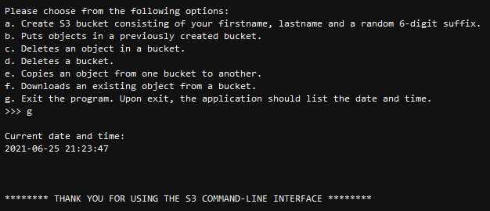

*Note*. From AWS Cloud9 IDE.

**Error Handling**

**Figure 15a**

*Main menu screen of application, showing invalid input response.*

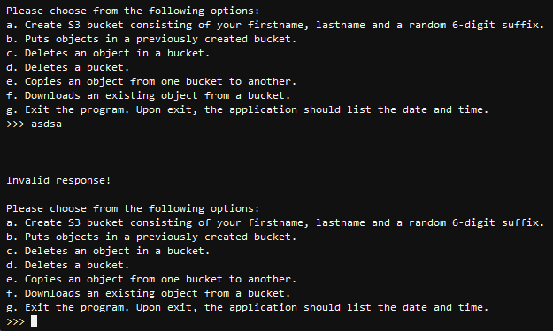

*Note*. From AWS Cloud9 IDE.

**Figure 15b**

*Main menu screen of application, showing error log of trying to delete a bucket that does not exist.*

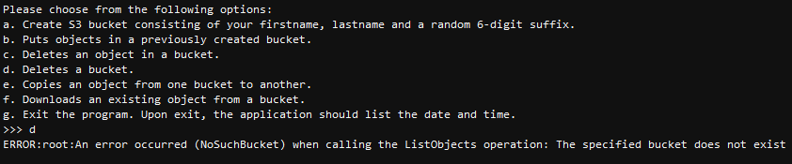

*Note*. From AWS Cloud9 IDE.

**Figure 15c**

*Main menu screen of application, showing error log of trying to delete object in bucket that does not exist.*

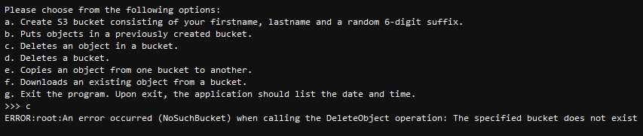

*Note*. From AWS Cloud9 IDE.

**Figure 15d**

*Main menu screen of application, showing error log of trying to put object in bucket that does not exist.*

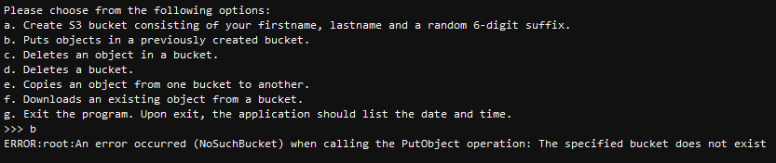

*Note*. From AWS Cloud9 IDE.

1. (20 points) Submit your documentation in Word or PDF format no later than the due date. This includes the following Submission details:
2. Page numbers should be included for all pages (except the title page) and be at the top right of the page.
3. Paragraphs should be double-spaced with 1" margins on all sides.
4. 12 pt. Times New Roman font or similar should be used.
5. Figures should have titles and numbers.
6. The document should contain minimal spelling and grammar errors.
7. References are included (you should reference the code used) and provided in APA format.

**References**

*copy_object.py*. (2019). [copy_object.py demonstrates how to copy an Amazon S3 bucket object.]. Amazon, Inc.

*create_bucket.py*. (2019). [Create_bucket.py demonstrates how to create an Amazon S3 bucket in any region.]. Amazon, Inc.

*delete_bucket.py*. (2019). [Delete_bucket.py demonstrates how to delete an empty Amazon S3 bucket.]. Amazon, Inc.

*delete_object.py*. (2019). [Delete_object.py demonstrates how to delete an object from an Amazon S3 bucket.]. Amazon, Inc.

*put_object.py*. (2019). [Put_object.py demonstrates how to add an object into an Amazon S3 bucket.]. Amazon, Inc.

*s3-python-example-download-file.py*. (2018). [S3-python-example-download-file.py demonstrates how to how to download a file (or object) from an Amazon S3 bucket.]. Amazon, Inc.